Name: Truong Tuyet Ngan

StudentID: SE171794

**VEGETABLE SHOP**

Software Requirement Specification

* HCM, August 2023 -

**I/ Overview**

1, Introduction

My project is about website that sells vegetable. Includes feature such as *login, registration, purchase, update.*

Database:

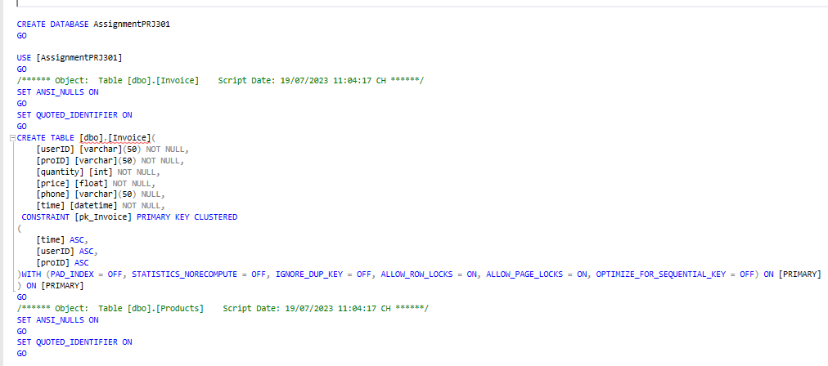

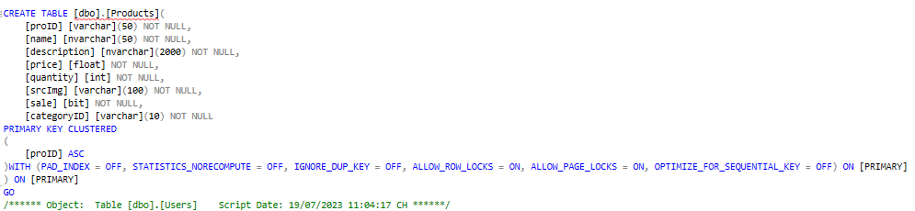

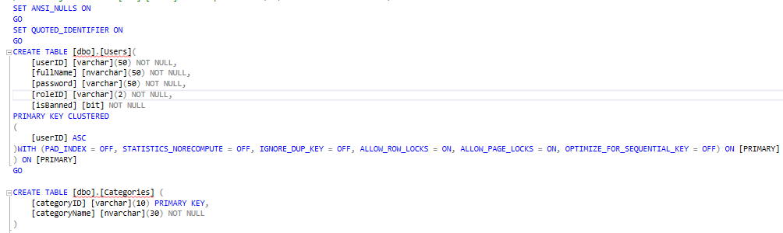

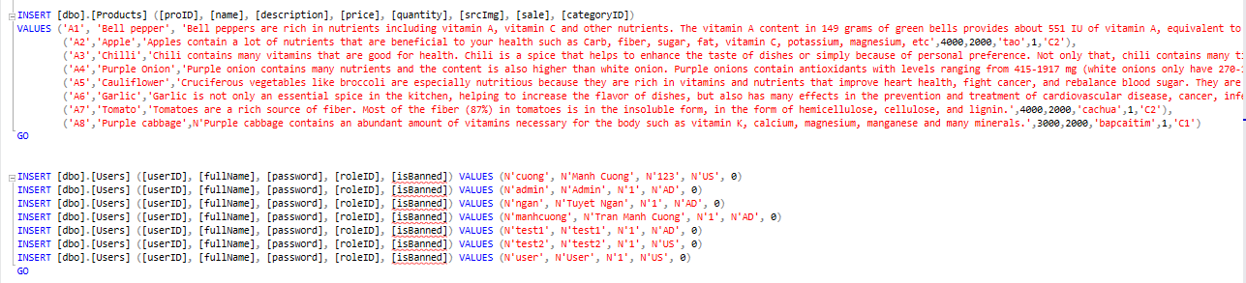

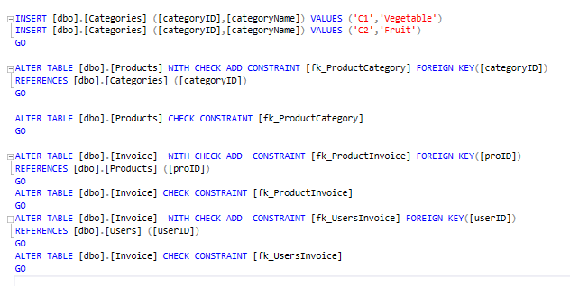

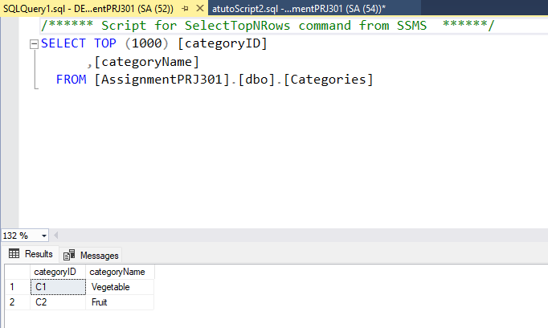

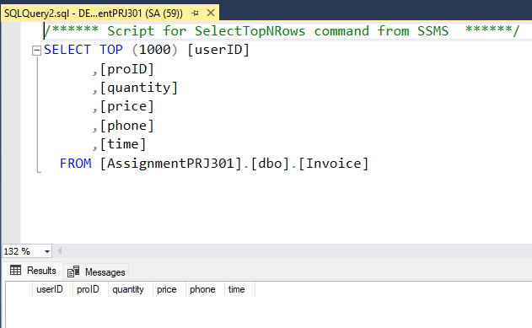

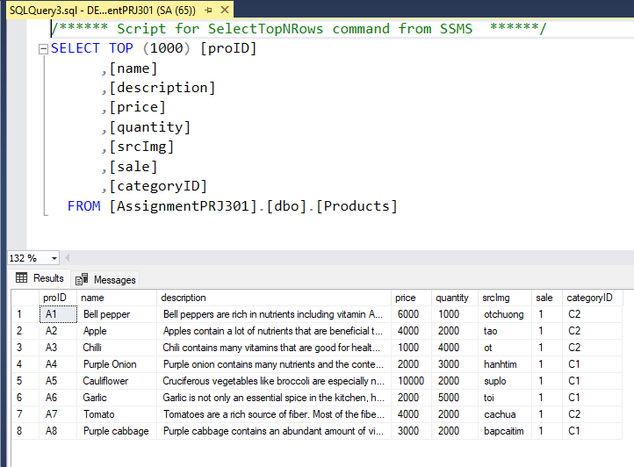

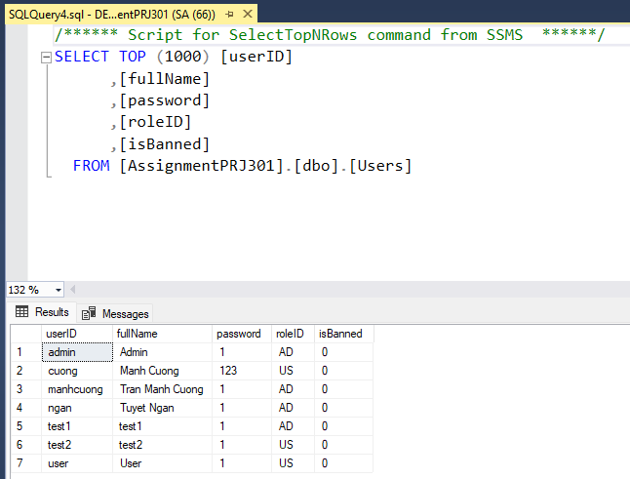

2, System Functions

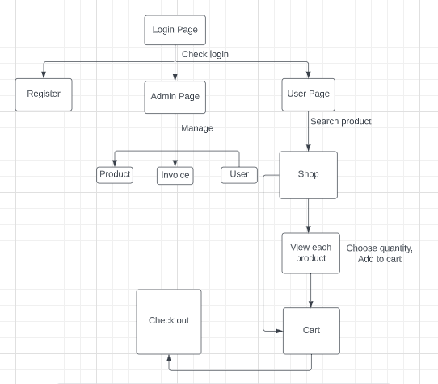%3CmxGraphModel%3E%3Croot%3E%3CmxCell%20id%3D%220%22%2F%3E%3CmxCell%20id%3D%221%22%20parent%3D%220%22%2F%3E%3CmxCell%20id%3D%222%22%20value%3D%22%22%20style%3D%22rounded%3D0%3BwhiteSpace%3Dwrap%3Bhtml%3D1%3B%22%20vertex%3D%221%22%20parent%3D%221%22%3E%3CmxGeometry%20x%3D%22288%22%20y%3D%22360%22%20width%3D%2272%22%20height%3D%2245%22%20as%3D%22geometry%22%2F%3E%3C%2FmxCell%3E%3C%2Froot%3E%3C%2FmxGraphModel%3E

**II/ Functional Requirements**

1, Login

Function trigger: after clicking Login button.

Function description: The system allows admin or user to use their username and password to log in to the system.

Screen layout:

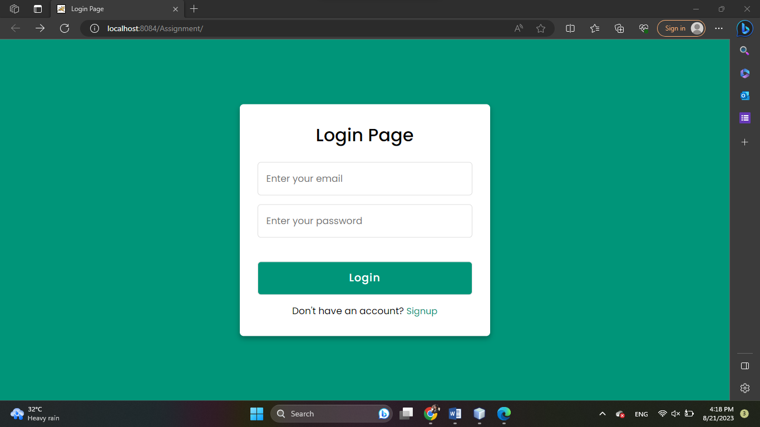

2, Register

Function trigger: after clicking Signup button.

Function description: The system allows users to register for an account.

Screen layout:

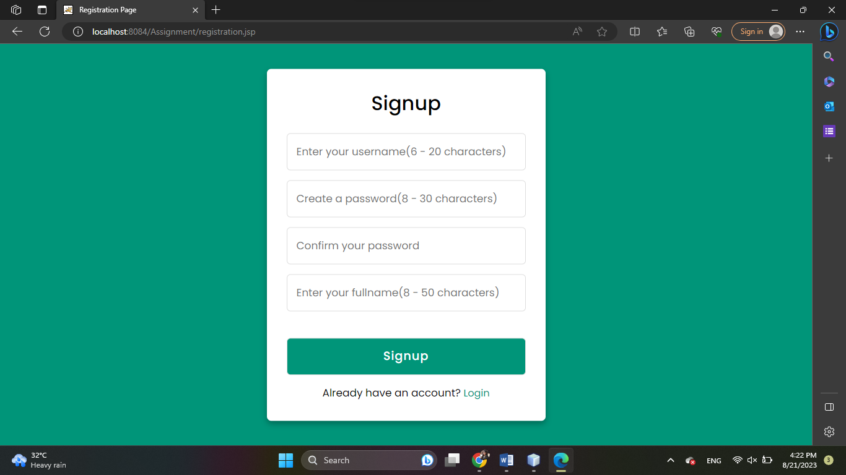

User web application

a, Show shopping page

Function trigger: after the User click button “Home” or “Login” or “Signup” successfully.

Function description: the system shows products to user

Screen layout:

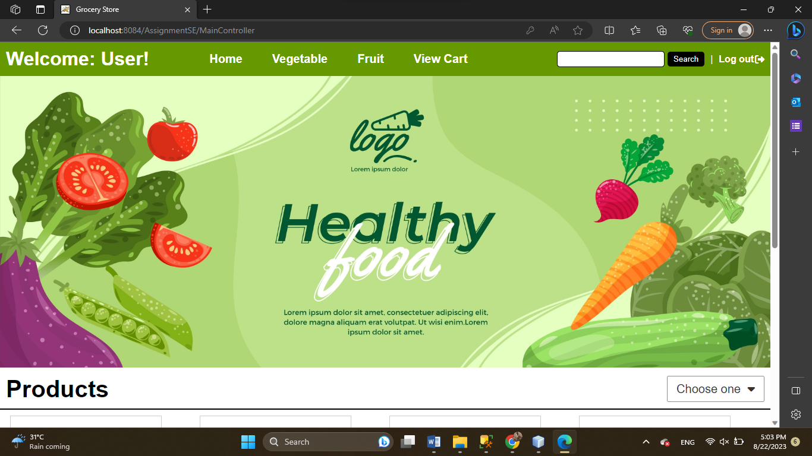

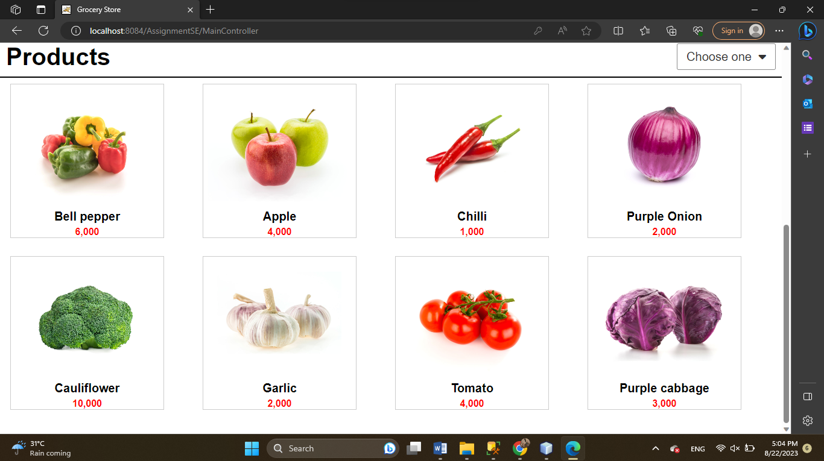

b, Search product by name

Function trigger: after input name of product clicking search button

Function description: Display products according to user’s search request

Screen Layout:

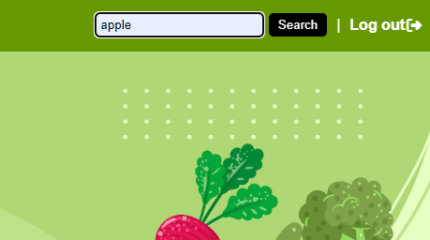

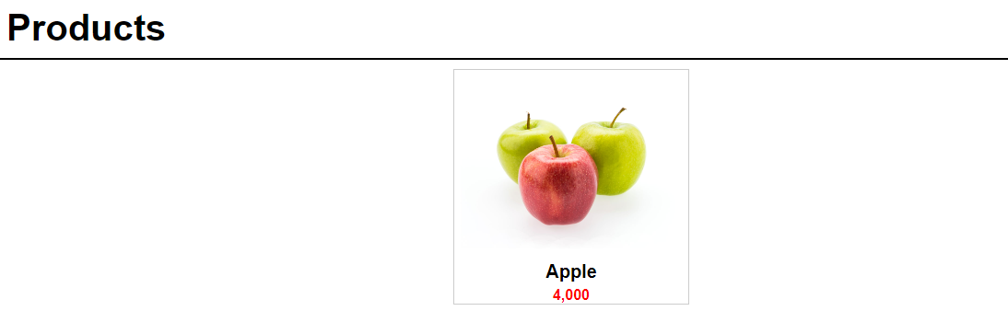

c, Search product by category

Function trigger: after click button “Fruit” or “Vegetable”

Function description: Display products according to user’s search request

Screen Layout:

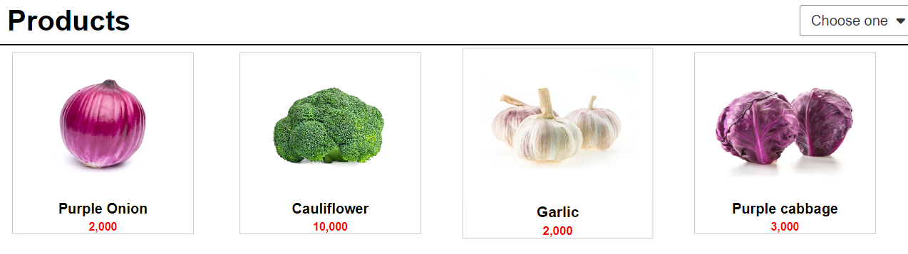

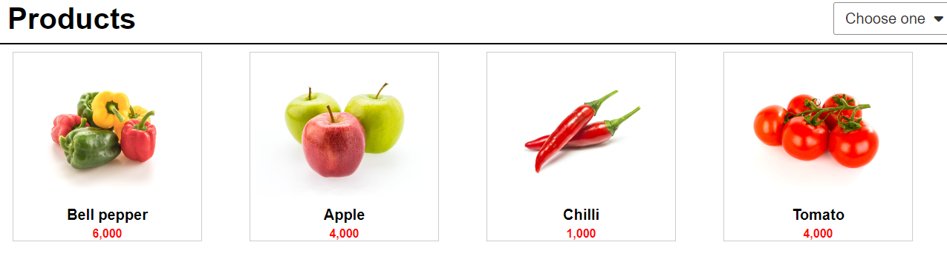

d, Search product by price

Function trigger: after click link “Choose one” .

Function description: Display products to select product range of price.

Screen Layout:

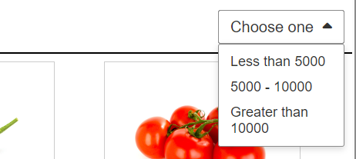

Product less than 5000 include:

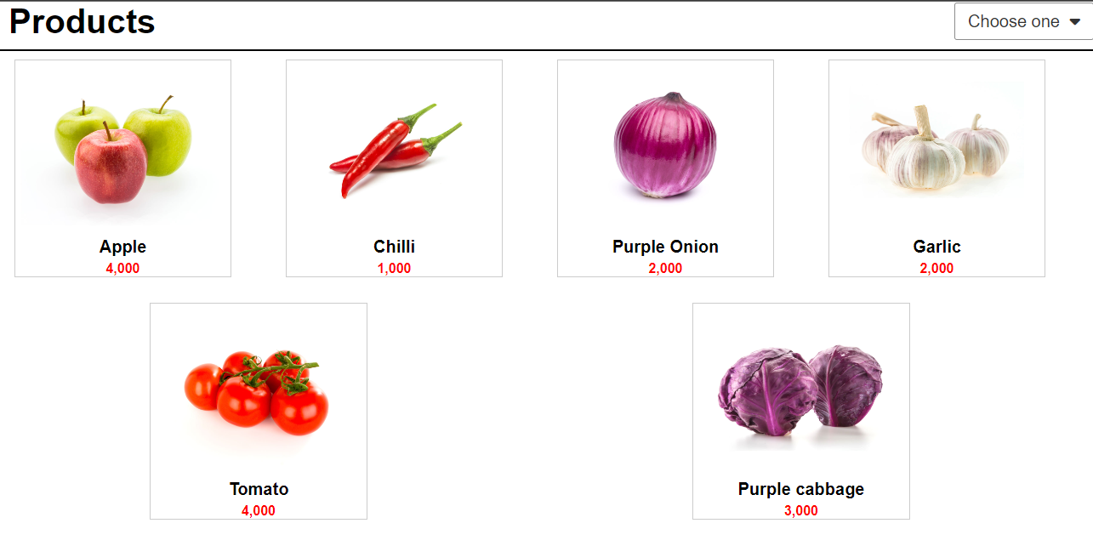

e, View product detail

Screen layout:

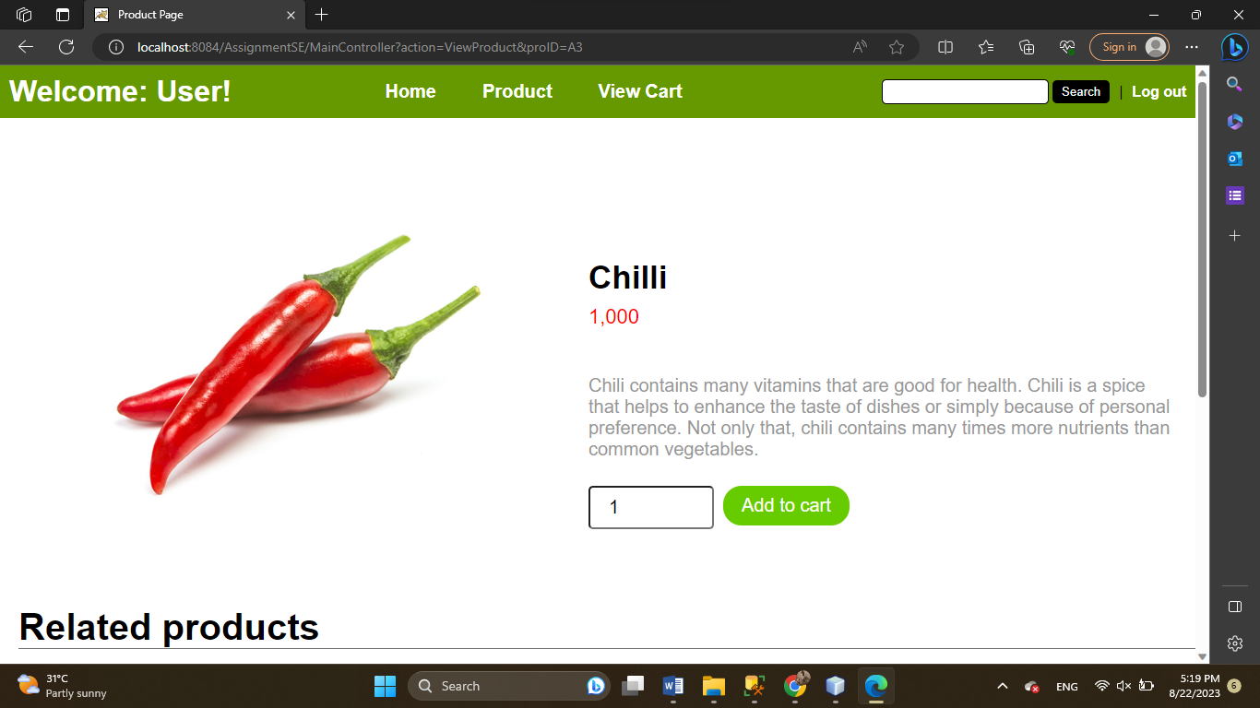

f, View cart

Function trigger: after choosing link View cart in header

Screen layout:

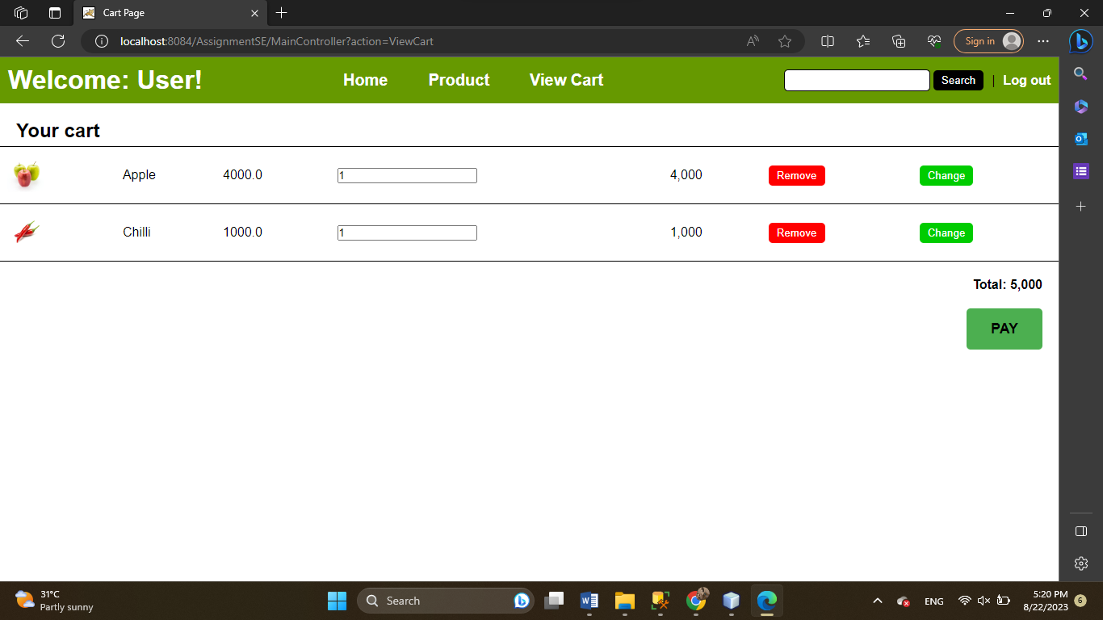

g, Pay

Function trigger: after choosing button PAY in Cart page

Function description: display an form to input phone number of consignee

Screen layout:

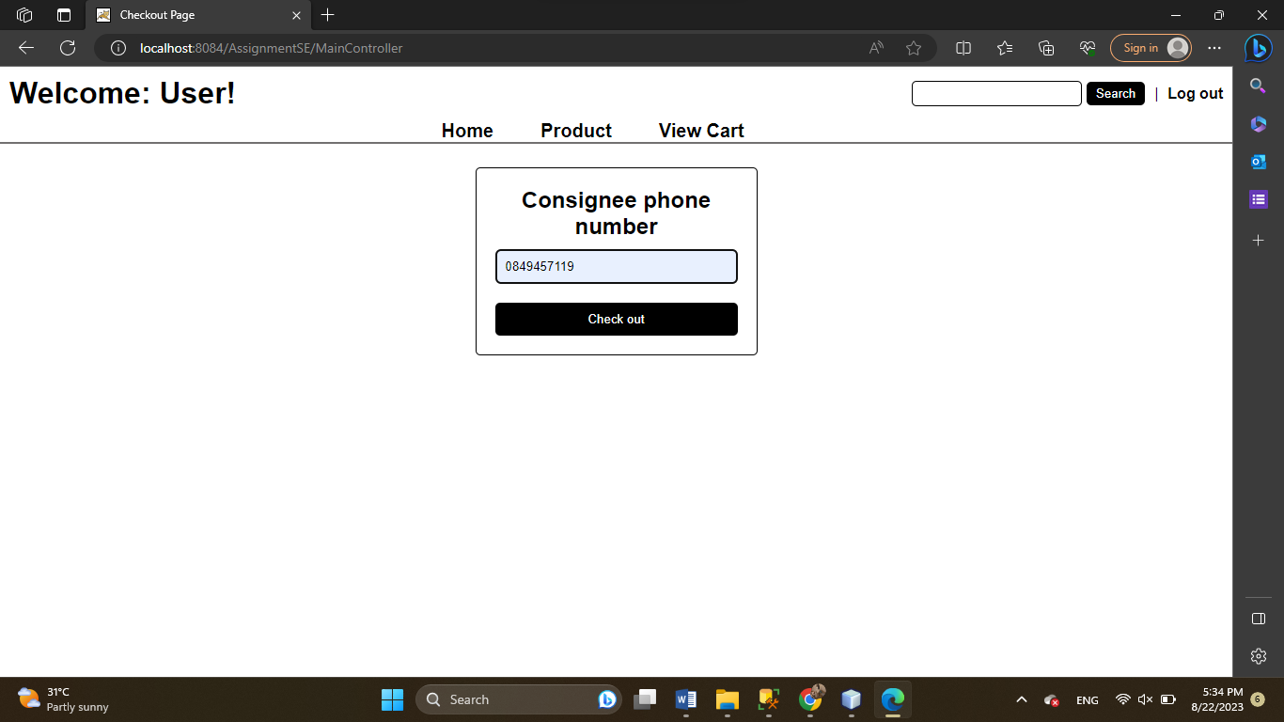

h, Notice of successful order

Function trigger: after clicking Check out

Function description: a success message is displayed on the screen

Screen layout:

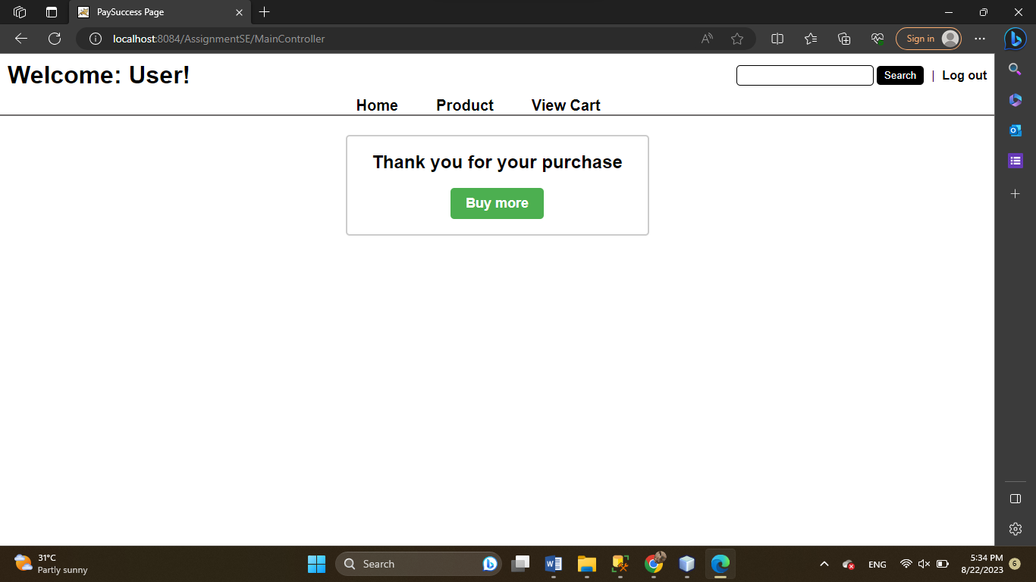

Admin Web Application

a, Manage product

Screen layout:

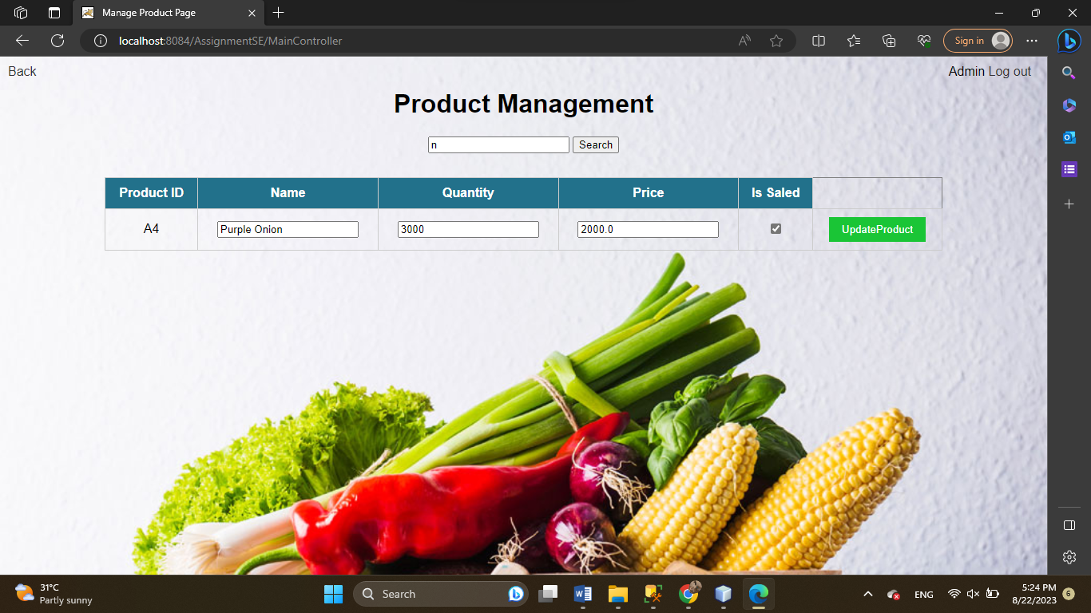

b, Manage user

Screen layout:

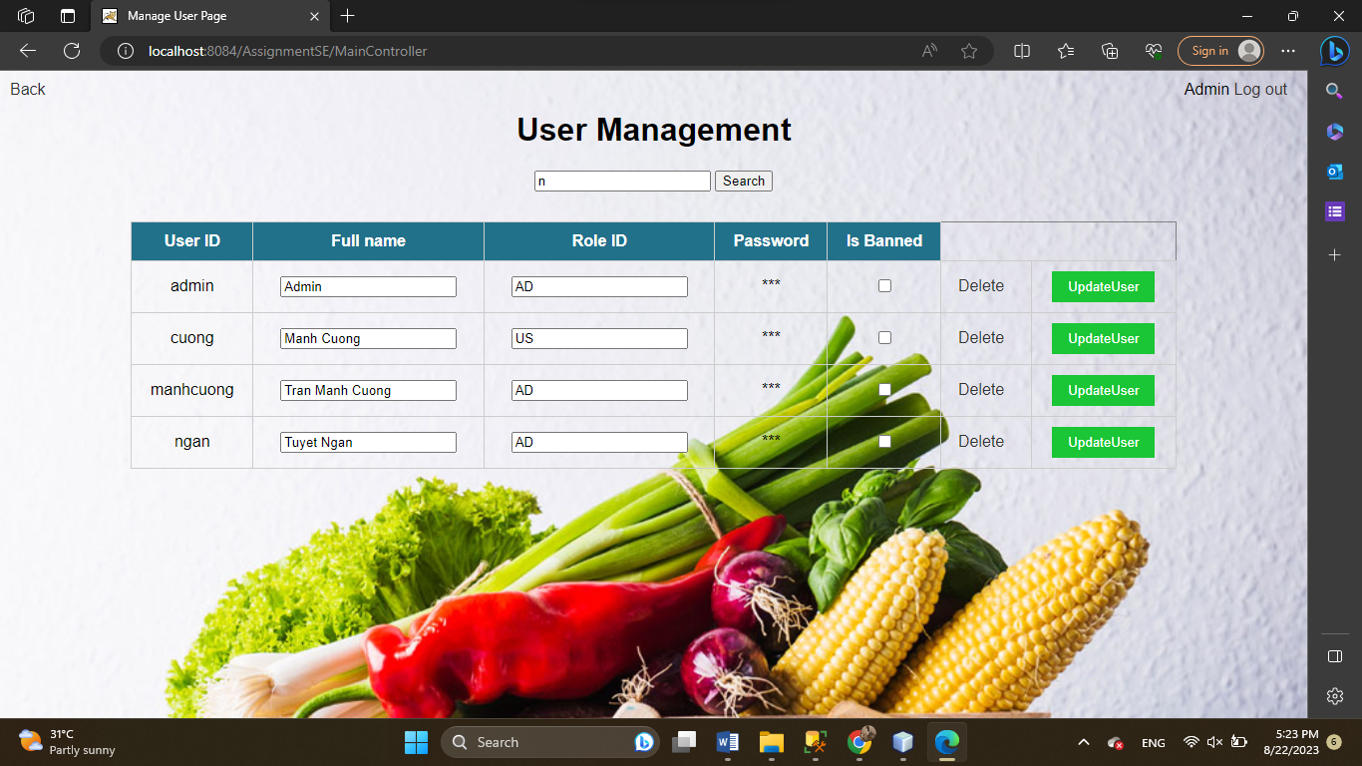

c, Mange invoice

Screen layout:

